**COMSATS University Islamabad,   
Park Road, Chak Shahzad, Islamabad Pakistan**

Project Proposal  
(SCOPE DOCUMENT)

for

**Curriculum Management and Administration System**

Version 1.2

***By***

**Raja Shayan Azad Khan CIIT/FA16-BSE-084/ISB**

**Noor-us-Sahar CIIT/SP17-BSE-011/ISB**

**Iqra Fareed CIIT/SP17-BSE-037/ISB**

***Supervisor*Dr. Hasan Ali Khattak**

***Bachelor of Science in Computer Science (2017-2020)***

**SCOPE DOCUMENT REVISION HISTORY**

|  |  |  |
| --- | --- | --- |
| **No.** | **Comment** | **Action** |
| **1.** | Context diagram is not visible. | We would like to thank the evaluates for rigorous evaluation. |
| **2.** | Students have yet not communicated with clients but providing a document mentioning all modules. | All comments have been incorporated and documents have been updated. |
| **3.** | It is a database project where a major line of code will be repeatedly used. Reports and analytics are required. | Indeed it is a database project but the efforts and output in such a complex and full of interactions project is required to satisfy the client and users. |
| **4.** | The project's scope is too long and modules are needed to be cut down. | After discussion with the supervisor the scope has been reduced. |
| **5.** |  |  |

**Supervisor Signature:  
Date:**

**Table of Contents**

**1.** **Introduction 1**

**2.** **Problem Statement 1**

**3.** **Problem Solution for Proposed System 1**

**4.** **Related System Analysis/Literature Review 2**

**5.** **Advantages/Benefits of Proposed System 2**

**6.** **Scope 2**

**7.** **Modules 4**

7.1 Module 1: Admissions 4

7.2 Module 2: Maintain Course Details 5

7.3 Module 3: Enrollment 5

7.4 Module 4: Class Scheduling 5

7.5 Module 5: Grading 6

7.6 Module 6: Student Academic History 6

7.7 Module 7: Faculty Record 7

7.8 Module 8: Communication 7

7.9 Module 9: Report Analysis. 8

**8.** **System Limitations/Constraints 8**

**9.** **Software Process Methodology 8**

**10.** **Tools and Technologies 9**

**11.** **Project Stakeholders and Roles 9**

**12.** **Team Members Individual Tasks/Work Division 9**

**13.** **Data Gathering Approach 10**

**14.** **Concepts 10**

**15.** **Gantt chart 11**

**16.** **Mockups 12**

**17.** **Conclusion 13**

**18.** **References 13**

**19.** **Plagiarism Report 14**

**Project Category: (**Select all the major domains of proposed project**)**



# Abstract

This project is basically dealing with the administrative side of the curriculum management portal. The basic purpose of the project is to make an easy and user-friendly product and provide an interface for the admin to collect and safely use the data without any compromise of student’s privacy.

The portal will store, create, maintain and manipulate data of students, faculty members, staff, departments, courses and examinations. The system automates the manual update and management of the data and keeps track of students from the time they apply for enrollment till they graduate. It keeps all kinds of necessary data i.e. if students are eligible for admission, personal information, previous educational record, contact information, semester progress, courses registered, teachers assigned, attendance, quizzes, assignments, semester grade, fee submission, scholarships. It also records teachers and staff required information. Therefore, this system is automating the manual processes and minimizing the risk of human error.

# Introduction

This is an online system which makes it easier for faculty to perform their daily tasks by automating the major activities that are being done manually. Faculty can register students online, upload and download assignments, see their attendance, upload lectures and quizzes of their general and hybrid courses and result cards. With the help of this system we can perform online surveys to get review and feedback for improvement. This system will cater to many problems faced by the administration systems, under one umbrella. It can track and update records of fee submission, salary payment and other financial tasks. This system will allow users to upload and download data within certain limits like (faculty can only upload field relevant content). User interfaces are designed according to the targeted audience, such as different interfaces will be provided for admin and faculty according to their roles and authority.

# Problem Statement

In this era of technology there are many problems faced by usage of manual systems such as calculating percentages, updating records, maintaining backups, fast searching and many other issues are faced by fast growing organizations, every semester hundreds of new students are enrolled and great number of them graduate while many students are promoted or they repeat the semester. Usually institutes save this kind of data in excel sheets but again there is not one specified and customized system which can handle all the fields at one platform. Admin can’t broadcast the notifications to all individuals at once in current systems and it is not easy for the admin to perform these operations since manual functionality requires more time and effort. Systems like these are currently absent in many institutions but they have some limitations like (sending separate notification systems regarding updates and announcements in the institutions and dealing with major administration-based activities at one platform), which we’ll rectify in our project. The major and most common problems are that they are very sensitive to human errors or mistakes like wrong entry of student’s credentials etc.

# Problem Solution for Proposed System

Our system will provide the solution towards these problems. Our system will keep track of the population in an institution. By using our system the administration use data for major purposes i.e. getting total population of specific departments, programs, semesters, courses, classes and identifying all the position holders of semester, to single out all the fee defaulters, to list out all dropouts, to list out all student’s whose attendance is below a certain criteria. By using our system surveys will be conducted to gather information about the inconveniences and problems faced by the users of previous systems. So that we can improve the user experiences as required. Our system will provide a single platform for the users to be updated with the latest news and events taking place in the institution.

It will be a platform for all admin-based activities i.e. (registration, maintaining/ modifying data, notifying admin and students, providing files for download and uploading for students or admin, confirmation of registration activities and validation i.e. accept/ reject request). Automation of these tasks will lead to time and cost saving for admin-based activities. Our system keeps track

of all the information regarding students and faculty members. Data processing takes place at run time like assessment evaluation and student attendance taking place online generating a graph of student attendance. The evaluation takes place automatically based on previous data and so does the generations of all forms and receipts based on the user requirements. Result evaluation is automated as expected results/ projected final marks are generated based on previous record of the student. Fee payment can be done online with an atm card. Admin can perform CRUD operations for students registered or new admissions.

# Related System Analysis/Literature Review

**Table 1 : Related System Analysis with proposed project solution**

|  |  |  |
| --- | --- | --- |
| **Application Name** | **Weakness** | **Proposed Project Solution** |
| CU Online | Simple but reduced | Interactive and easy to learn |
|  | functionality offered to | user interface with more |
|  | admin. | functionality. |
| CMS nust | Weakness is that courses | Combining both the portal |
|  | are dealt on another portal | functionalities and making a |
|  | one platform is not dealing | unified system. |
|  | major functionality. |  |



# Advantages/Benefits of Proposed System

* + It will provide one single platform that deals with all admin activities.
  + Reduced man power will be required, as we are providing a system that is taking functionalities from manual to automated.
  + There is a version control/ backup our system will provide especially in the case of data loss or system crash.
  + Our system is providing ease of access by making the system more understandable and usable.
  + Our system provides an online fee management system as admin can be responsible for payment and transaction approval.
  + It provides the platform for communication for faculty and students both.

# Scope

The proposed system will a web interface. In our Curriculum Management System, the user will have the following roles i.e. role of an administration and management. As an administrator he will have roles to manipulate the data of the students. Along with that he will be able to access all the essential information of students and faculty. They will also be able to oversee all the student services, academics, faculty research at colleges and universities, curriculum choices and financial aid, student recruiting, admissions, scholarships and student affairs.

The System will be designed for administration-based activities which involve managing student details and maintaining a record of all student information. It will automate the faculty and admin activities saving time and effort. This will be done by dealing with all the issues regarding students and faculty through this automated system by providing online notifications about the latest news regarding the decisions and plans introduced in the university, to which students or faculty will be able to timely react.

Majority of management activity will be automated as well increasing productivity like updating class timetables and calendar, managing curriculum related activities i.e. course details and maintaining study area. Also, they will be able to manage student enrollment and students’ academic history, along with timely updates for example an update to the grading policy of the university. The system will be able to provide directions for the campus to improve their status by receiving the student and faculty responses, that are going to be recorded in the Performa’s being filled at the end of each session/ semester. Our system will provide administration with less workload and easy management by automation of the majority of tasks that are being performed manually on a regular basis by achieving the targets above and much more.

Our proposed system will be working on the information gathered from students and making decisions on it. Each student's information will be having a separate log maintained for their future record and tracking activities.

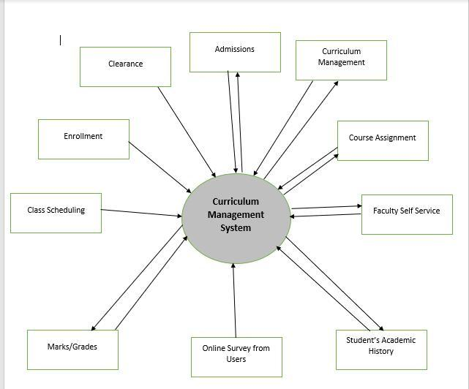

# Modules

## Module 1: Admissions

1. Admin shall be able to specify a start date and deadline for the form submission.
2. System shall display the registration form which will have applicants personal information like address, name , phone number, place of birth  etc. , previous academic information , guardian’s information , income information.
3. The applicants of bachelors shall be able to apply only through the admission test offered by the university.
4. The applicants applying for masters degree shall be able to add their NTS marks.
5. System will provide an option for applicants to upload their documents i.e., cnic / b-form , f.sc result or equivalence of A level , matric result or equivalence of O level, birth certificate , domicile.
6. This form will be available for applicants to fill it online while applying.
7. The admin shall be able to set the criteria for the different programs. i.e., 45% marks in HSSC plus SSC and background of physics for bachelors.
8. The system shall check if  the academic information matches the required criteria set by the administration.
9. The system shall forward the applications that are verified  according to the criteria , to the department.
10. The system shall send an email to the applicants whose applications are not matching criteria after verification.
11. The applicants will be able to resubmit their applications within the provided due date in the email.
12. The resubmitted forms will be verified and checked for authenticity before being forwarded to the department.
13. The approved applicants shall be sent an email having information regarding their entry test.
14. The admin shall be able to upload the entry test marks of the applicants.
15. The system shall calculate the aggregate of applicants HSSC or O levels, SSC or A levels , entry test marks (if applying for BS) and NAT (if applying for MS).
16. The system shall display the calculated aggregate on the applicant’s form which the applicant will be able to view.
17. The system shall use sorting algorithm to sort the applications in descending order i.e. starting from the highest merit score.
18. The admin shall be able to set the deadline for the display of merit list.
19. The admin shall be able to set the deadline of fee submission.
20. The system shall display the merit list of 1st 100 students when the deadline is achieved.
21. The system shall notify candidates that they are accepted through email.
22. The admin shall be able to update the fee information of applicants in the merit list when their fee is received.
23. The system shall reject the applicants whose fee has not been received when the deadline is arrived.
24. The system shall check the number of seats that are left according to admission fee submission status of students.
25. The system shall display the new merit list if seats are left of the next remaining applicants.
26. The system shall close the admissions after the available seats are completely reserved.
27. The system will generate offer letters for the selected applicants.
28. The system shall add the information of enrolled students in the database.

## Module 2: Maintain Course Details

1. The admin will be able to store all the course related information including CLOS, PLOS, credit-hours, pre/post-requisite, lab(if any) ,lab manuals , category(major/minor), instructors.
2. The system will also alert the applicants that if the course is compulsory/ advisory prerequisites.
3. The system will maintain the permissible range of course score, overall examination score, overall continuous assessment score governing the determination of course result grade before the semester starts.
4. The admin will be able to define the criteria for the calculation of the overall examination marks based on component scores, if any, and the final course score based on the continuous assessment and examination scores. This will include relative and absolute grading.(grading done on these basis)

## Module 3: Enrollment

1. The admin will be able to set criteria for enrolling a course , i.e., pre-requisites of a course must be completed in order to be enrolled in it.
2. The admin will be able to enroll students in courses in particular class and section.
3. The system shall be able to display all the courses of the related programs with checkboxes so the student can select courses they want to enroll in , selected courses will then be directly added in the database.
4. The admin will be able to enroll the batch of students .
5. The admin will be able to display the population of the students in particular class , section or course
6. The system will be able to select students and classes on the basis of these parameters such as Departments, School, Campus etc

## Module 4: Class Scheduling

1. The system will apply a timetable scheduling algorithm based on the courses offered to faculty.
2. As if the faculty is offered 2 sections and he/she is teaching the same course in them their timetable will be adjusted accordingly to avoid the clash.
3. The solution can be configured to import a generated class timetable from an external package or has its own timetable component.
4. The system will use a class strength scheduling algorithm for the sections to be divided based on the batch strength that has cleared the previous semester.
5. The solution provides a web-based facility for enquiries on the published class timetable.
6. The solution uses a "shopping basket" i.e. (timetable selection for elective courses) concept, where students can select a variety of classes and validate that they meet the class pre- requisites for course registration and upon completing enrolment, looks at their resultant personalized class timetable.

## Module 5: Grading

1. The admin will be able to set the assessment parameters to define the criteria of calculation of assignment, quizzes and mid term marks, of a course at the beginning of a semester.
2. The faculty will be able to enter marks of  quizzes / assignments of students of a certain course.
3. The faculty will be able to make changes in the marking of assignments or quizes of a course before the deadline.
4. The system will calculate the total marks and gpa of the course.
5. The system will allow designated authorities to modify the grades/ marks of the underlying categories such as Final, Mid-Term etc. that make up the final grade after the grade had been posted.
6. The faculty will be able to evaluate final grades after the terminal exams are taken at the end of each semester.
7. The system will update the final grades  automatically once the underlying marks/grades are changed.
8. The admin will be able to set a time period before the final result in which students will not have access.
9. The system will deny the portal access to the students for a period of time set by the admin to upload final marks. These results will then be viewable later on after the access is again granted to students.
10. The admin will be able to define 3 levels of assessment requirements at course level, component level, etc. e.g. Course A will have Field Work, Course Work, Project, Attendance, Exam as Level 1 assessment requirements. Level 1 “Project” assessment will have Level 2 assessments such as “Group Project” and “Individual Project”. Level 3 assessments for “Group Project” can then be broken down into “Teamwork” and “Leadership skill” while “Individual Project” can be broken down into “Essay Writing” and “Presentation Skills”. Different weightages may be applied at various levels.

## Module 6: Student Academic History

1. The admin will be able to add the record of students i.e. secondary and tertiary education details, overseas educational details (if available), courses studied, progression status, GPA, individual subject marks, withdrawal courses etc.
2. The admin will be able to update and modify the details of students.
3. The admin will be able to view and have access to student’s details.
4. The student will be able to add their contact information in the system.
5. The system will keep track of the students work experience, outcome of tests, other qualifications and other qualifications including scores on sub-tests.
6. The system will maintain the student results and outcomes in the context of their performance in quizzes, assignments and mid-term exams.
7. The admin faculty and student will be able to view enrollment reports, graduation and demographic stats.
8. Once the record has been created it will become part of the student record.

## Module 7: Faculty Record

**M7F1: Faculty Center:**

1. The admin will be able to add a new faculty member.
2. The admin will add his/her information such as: address, name , phone number, date of birth, CNIC, specializations, previous records of their achievements which include (their past projects, courses taught, courses being taught currently and researches going on etc.), bank details for transactions (salary) and educational information.
3. The admin will be able to provide a calendar for faculty to mark their free time slot based on their availability for scheduling meetings with students, admin or other faculty members.
4. The admin will be able to update the information of faculty when there is a new course being taught by them or either they have completed a new research paper they were working on earlier.
5. The admin will be able to delete the information of the faculty after they have resigned or their contract with the university has ended.
6. The faculty will be able to change their own information as per their present updated information.
7. The result of evaluation of previous teaching done by the system through proformas is added in the faculty’s record.
8. The admin will be able to mark faculty’s attendance.

**M7F2: Faculty Self Service:**

1. The faculty will be able to access information via the faculty centre.
2. The faculty will be able to view their teaching schedule online.
3. The faculty will be able to edit their free and reserved slots in the provided calendar by the admin.
4. The faculty will be able to view attendance on their profile.

## Module 8: Communication

1. The system will use chat api for communication purposes.
2. The communication can take place between student and faculty, admin and faculty, admin and student as well as faculty to faculty and admin to admin.
3. The user will be able to send the message through the chat box.
4. The user will  get notified about the message by the red mark on the notification icon.
5. The user shall view the messages and reply to them as per their required context.
6. Admin shall only be able to send the no-reply messages to either faculty or students.
7. The system shall be able to send auto generated responses to FAQ’s of students using classification algorithms for the common words being used in the messages.
8. There shall be static FAQ’s available to provide solutions to queries related to login, forget password and missing deadline to guide the user through the process of gaining access to their profile again.
9. Users will be able to send attachments in the chat.
10. The faculty will be able to create a group on the basis of class to have a group communication

## Module 9: Report Analysis.

1. The system will support performing surveys (like HEC performa) from users i.e.Student Course Evaluation Questionnaire Proforma ,Faculty Course Review Report Performa,Survey of Graduating Students Performa ,Research Student Progress Review Form,Faculty Survey Proforma ,Survey of Departments Offering PhD Program Performa ,Alumni Survey ,Employer Survey ,Faculty Resume Form ,Teacher Evaluation Form.
2. The faculty and admin will be able to generate reports of students grades and performance.
3. On the basis of the results of these proformas systems will generate and display a graphical representation of the results.
4. The admin shall be able to view these reports.

# System Limitations/Constraints

* + Time span our system can retain data is 10 years, apart from major/ important data like (degree, fee information etc.), to the point it was generated.
  + Size of files uploaded by users will be limited upto a certain capacity.
  + Session duration will be limited to the point if the user does not navigate on the page for 15 minutes the session will expire and the user will have to login again.

# Software Process Methodology

Incremental model will be used for the project development life cycle because the project is module based and the modules will be developed one by one. New modules can be added to the system as per the committee needs.

# Tools and Technologies

**Table 2Tools and Technologies for Proposed Project**

|  |  |  |  |  |
| --- | --- | --- | --- | --- |
|  | **Tools** |  | **Version** | **Rationale** |
|  |  |  |  |  |
|  | MongoDB Compass |  | 4.2.2 | DBMS |
| **Tools** | Community |  |  |  |
|  |  |  |  |
| VS code |  | CSC 6 | Design Work |
| **And** |  |
|  |  |  |  |
| Postman |  |  | API Testing |
| **Technologies** |  |  |
| **Technology** |  | **Version** | **Rationale** |
|  |  |  |  |  |
|  | MongoDB |  | 5 | NoSQL database |
|  |  |  |  |  |
|  | JavaScript |  | 1.8.2 | Query Language |
|  |  |  |  |  |
|  | REACT Js |  | 16.9.0 | Web Framework |
|  |  |  |  |  |
|  | Node JS |  | 0.10.36. | Backend Language |
|  |  |  |  |  |
|  | React Native |  | 0.59 | Cross platform mobile |
|  |  |  |  | development |
|  |  |  |  |  |
|  | Express JS |  | 4.0 | Backend Development |
|  |  |  | |  |

# Project Stakeholders and Roles

**Table 3Project Stakeholders for Proposed Project**

|  |  |
| --- | --- |
| **Project** | COMSATS University, Islamabad |
| **Sponsor** |
|  |
|  |  |
| **Stakeholder** | * Department of Physics Benazir Bhutto University Peshawar * Raja Shaiyan Azad Khan (FA16-BSE-084) * Noor us Sahar (SP17-BSE-011) * Iqra Fareed (SP17-BSE-037) * Dr. Hasan Ali Khattak * Final Year Project Committee |
|  |
|  |  |

# Team Members Individual Tasks/Work Division

**Table 4Team Member Work Division for Proposed Project**

|  |  |  |
| --- | --- | --- |
| **Student Name** | **Student Registration Number** | **Responsibility/ Modules** |
| Shaiyan Azad | FA16-BSE-084 | All queries that may relate to the front end. |
|  |  | Modules: 1,2,3 |
|  |  |  |
| Noor us Sahar | SP17-BSE-011 | Backend. |
|  |  | Modules:4,5,6 |
|  |  |  |
| Iqra Fareed | SP17-BSE-037 | Documentation. |
|  |  | Backend |
|  |  | Modules:7,8,9 |
|  |  |  |

# Data Gathering Approach

The following are the data gathering approaches that will be used in our project.

* Interviews: Interviews are being conducted from the faculty and admin for the purpose that we will be able to get feedback on their user experience and deal with all the drawbacks of the existing system. So that we can improve our system and cater to all their issues.
* Questionnaire Proforma: This will be used to get feedback and draw conclusions of customer and user needs.
* Study of past similar systems: This will be conducted to ensure what features the current systems are lacking in them so that we can provide a much better and improved alternative.

# Concepts

Concept-1: ***MERN Stack and Web Development:***

*MERN is an abbreviation for MongoDB, Express JS, React JS and Node JS. It is based on JavaScript for development of web applications which is the modern way of developing a web-based system.*

# Gantt chart

Create the Grant Chart and provide estimated start and end dates of all proposed modules/tasks for each team member. Also identify the dependencies (which tasks cannot be started/completed, until the dependent task is completed). Gantt chart can be created using MS Project.

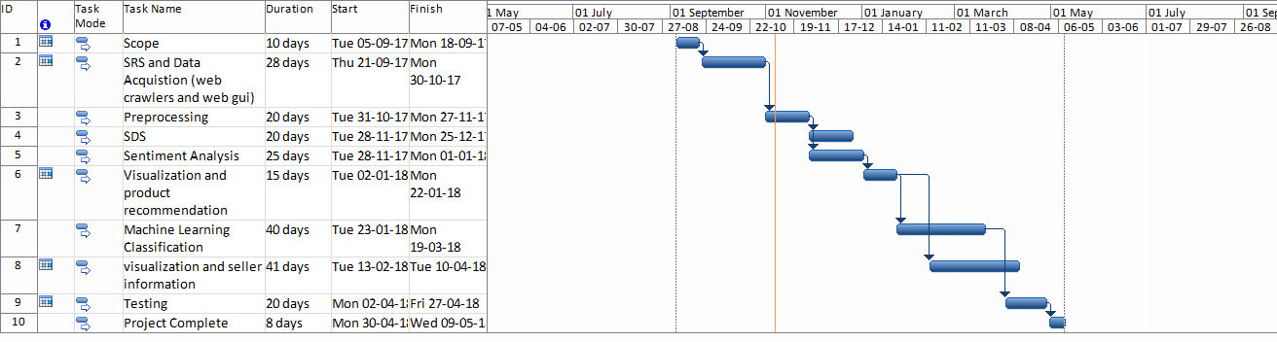

# Mockups

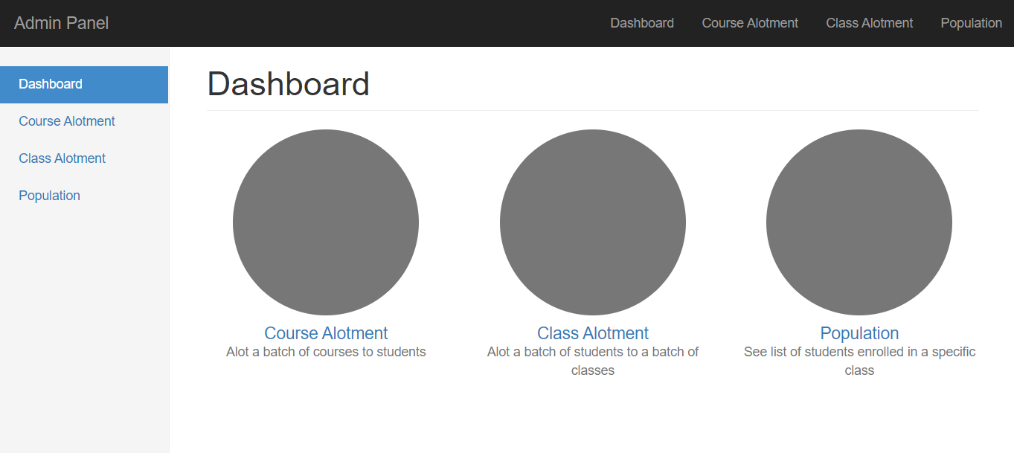

**Figure 1: Dashboard 1**

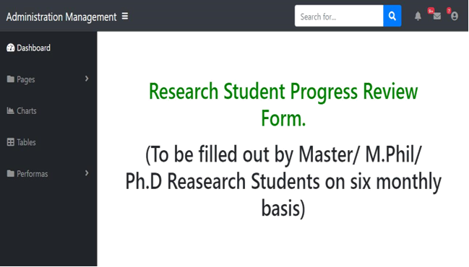

# Conclusion

Curriculum Management and Administration system can be used in universities. This will provide the faculty and admin staff with basic facilities to provide ease in their daily tasks and make them faster and efficient. This system will provide the faculty with their own functionalities and will provide the admin with ease to maintain, store and edit records and have access to all the records.

# References

1. Watson, E. G., Moloney, P. J., Toohey, S. M., Hughes, C. S., Mobbs, S. L., Leeper, J. B., & McNeil, H. P. (2007). Development of eMed: a comprehensive, modular curriculum-management system. *Academic Medicine*, *82*(4), 351-360.
2. Encyclopedia of Portal Technologies and Applications , Arthur Tatnall , Victoria University , Australia.
3. <https://www.skyward.com/k-12/student-information-system/office-and-administration/brief/curriculum-management>
4. <http://www.escholaris.com/>

# Plagiarism Report

Attach the Plagiarism report of your project scope document from library staff of turnitin tool (<http://turnitin.com>)